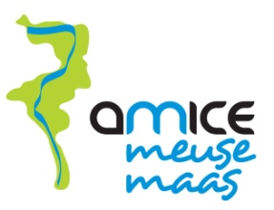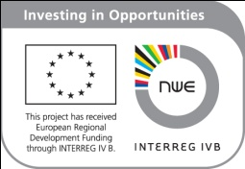

REGISTRATION FORM

AMICE site visit to the Rur reservoirs (D)
April 6th – April 7th 2011

NAME :
ORGANISATION :

Will come and discover this AMICE investment : YES/NO

Will attend the afternoon session (starting 4.00 pm) on Wednesday 6th: YES/NO

Will participate in the guided tour on Wednesday evening : YES/NO

Will have dinner with us on Wednesday : YES/NO

Will stay in Aachen : YES/NO. Attention : you need to make your own reservation before March 28th, see programme.

Will participate in the site visit on Thursday April 7th : YES/NO

Please send the completed form back to martine.lejeune@riou.be before March 31st

